Project Planning Phase
Project Planning Template (Product Backlog, Sprint Planning, Stories, Story points)

Date | 01 November 2026
Team ID | NA
Project Name | Electric Vehicle Market Performance & Insights
Maximum Marks | 8 Marks

Product Backlog, Sprint Schedule, and Estimation (4 Marks)
Use the below template to create product backlog and sprint schedule
Sprint | Functional Requirement (Epic) | User Story Number | User Story / Task | Story Points | Priority | Team Members
Sprint-1 | Data Collection | USN-1 | Get the cleaned EV dataset (ev_market_clean.csv) | 2 | High | Riya Sharma
Sprint-1 | Data Preparation | USN-2 | Connect to Tableau, check types, create extract | 3 | High | Riya Sharma
Sprint-1 | Data Preparation | USN-3 | Create KPI calculated fields and Model Year Label | 3 | High | Riya Sharma
Sprint-1 | Planning | USN-4 | Map the 3 scenarios to business questions | 2 | High | Riya Sharma
Sprint-2 | Visualisation | USN-5 | EV Performance Snapshot (KPIs) | 2 | High | Riya Sharma
Sprint-2 | Visualisation | USN-6 | Sales Share by Market Region (treemap) | 2 | High | Riya Sharma
Sprint-2 | Visualisation | USN-7 | Sales Trend by Market Region (line) | 2 | High | Riya Sharma
Sprint-2 | Visualisation | USN-8 | Battery Type Sales by Region (heatmap) | 3 | High | Riya Sharma
Sprint-2 | Visualisation | USN-9 | Battery Capacity by Category | 2 | High | Riya Sharma
Sprint-3 | Visualisation | USN-10 | Energy Efficiency by Category | 2 | High | Riya Sharma
Sprint-3 | Visualisation | USN-11 | AC Charging Time by Battery Type | 2 | Medium | Riya Sharma
Sprint-3 | Visualisation | USN-12 | Motor Power by Drivetrain | 2 | Medium | Riya Sharma
Sprint-3 | Visualisation | USN-13 | Price vs Insurance Cost (scatter) | 2 | Medium | Riya Sharma
Sprint-3 | Dashboard & Story | USN-14 | EV Technology Dashboard with 3 filters + 3-point Story | 5 | High | Riya Sharma
Sprint-4 | Deployment | USN-15 | Publish to Tableau Public | 2 | High | Riya Sharma
Sprint-4 | Testing | USN-16 | Performance testing and value checks | 3 | High | Riya Sharma
Sprint-4 | Documentation | USN-17 | Templates and final report | 3 | High | Riya Sharma
Sprint-4 | Demonstration | USN-18 | Demo video | 2 | Medium | Riya Sharma
Sprint-4 | Deployment | USN-19 | GitHub repository | 2 | Medium | Riya Sharma

Project Tracker, Velocity & Burndown Chart: (4 Marks)
Sprint | Total Story Points | Duration | Sprint Start Date | Sprint End Date (Planned) | Story Points Completed (as on Planned End Date) | Sprint Release Date (Actual)
Sprint-1 | 10 | 1 Day | 30 Oct 2026 | 30 Oct 2026 | 10 | 30 Oct 2026
Sprint-2 | 11 | 1 Day | 31 Oct 2026 | 31 Oct 2026 | 11 | 31 Oct 2026
Sprint-3 | 13 | 1 Day | 01 Nov 2026 | 01 Nov 2026 | 13 | 02 Nov 2026
Sprint-4 | 12 | 1 Day | 02 Nov 2026 | 03 Nov 2026 | 12 | 03 Nov 2026

Velocity:
Imagine we have a 10-day sprint duration, and the velocity of the team is 20 (points per sprint). Let’s calculate the team’s average velocity (AV) per iteration unit (story points per day)
For this project: 48 story points over 4 one-day sprints. Velocity = 48 ÷ 4 = 12 points per sprint; Average Velocity = 12 ÷ 1 day = 12 points per day.


Burndown Chart:
A burn down chart is a graphical representation of work left to do versus time. It is often used in agile software development methodologies such as Scrum. However, burn down charts can be applied to any project containing measurable progress over time.
Burndown chart of this project:
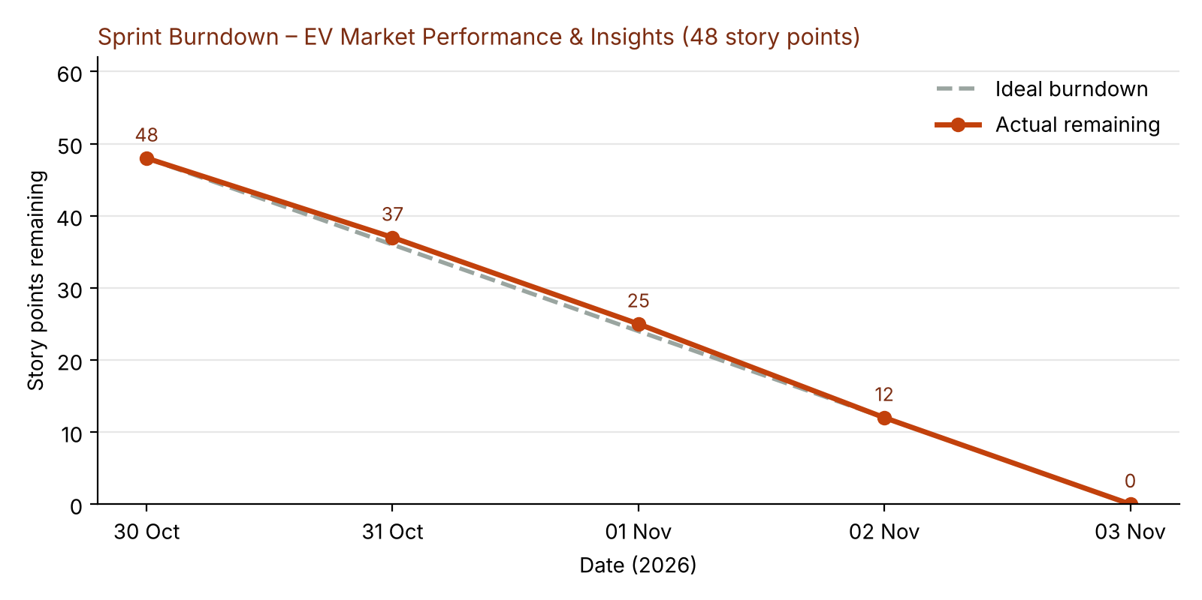

https://www.visual-paradigm.com/scrum/scrum-burndown-chart/
https://www.atlassian.com/agile/tutorials/burndown-charts

Reference:
https://www.atlassian.com/agile/project-management
https://www.atlassian.com/agile/tutorials/how-to-do-scrum-with-jira-software
https://www.atlassian.com/agile/tutorials/epics
https://www.atlassian.com/agile/tutorials/sprints
https://www.atlassian.com/agile/project-management/estimation
https://www.atlassian.com/agile/tutorials/burndown-charts

